**LAB # 08**

**Multiplexer**

**Objective**

To observe the working of multiplexer using 74151 IC.

**Requirement**

* 74151 IC
* LED
* Resistors
* Jumper wires
* Breadboard
* 5 Volt DC Power Supply

**Theory**

Multiplexer means many to one. A multiplexer is a combinational circuit with many inputs but only one output. By using control signals (select lines) we can select any input to the output. Multiplexer is also called as data selector because the output bit depends on the input data bit that is selected. The general multiplexer circuit has 2n input signals, n control/select signals and 1 output signal.

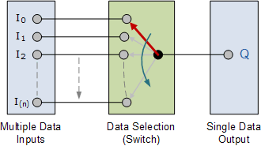

**Procedure**

Design circuit using Pin configuration of 74151 IC on MultiSim. Also observe truth table.

***(Send multisim file to the email id provided to you by your instructor)***

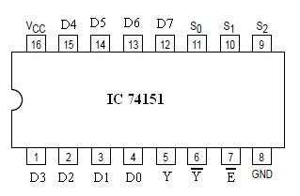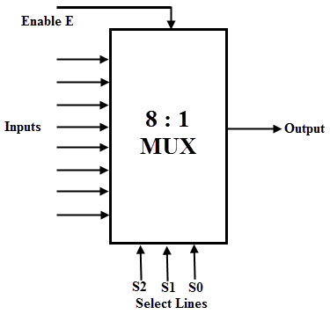

Pin configuration of 74151

Block diagram for 8:1 Mux

**Function Table**

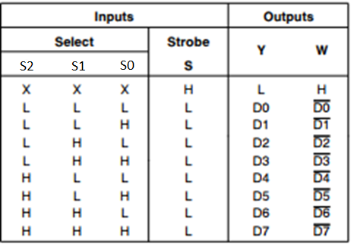

**Question**

* Write logic equation for 8:1 Mux.
* Draw the output waveform in relation to the inputs.

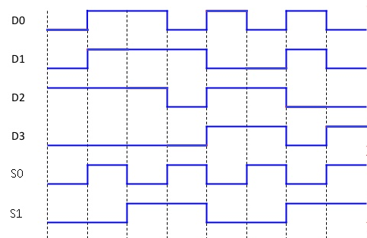

* Draw logic diagram for 8:1 Mux.